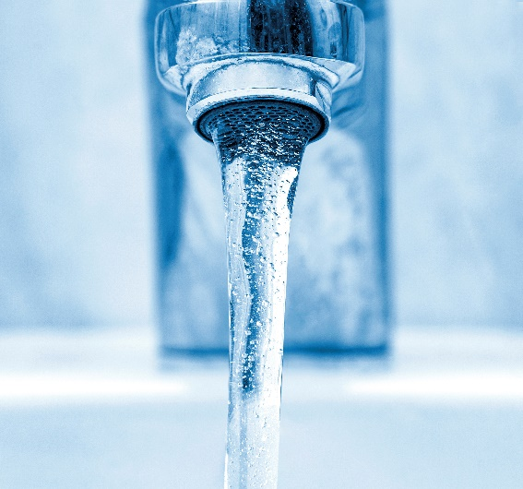
WORRIED ABOUT WATER?

Join us for a discussion about water affordability, and learn what you can do!

Attend this FREE workshop:
VENUE
ADDRESS
DATE
TIME

REGISTER TODAY!
• Call us at PHONE NUMBER
• Go online to REGISTRATION LINK

ORGANIZATION LOGO(S)

